Project 1
<American checker>

CIS-5 45779
Name: Chen, Jiahan
Date: 7/17/2019
Introduction
Title: American checker
American checker is a strategy board game for two players.
Checkers is played by two players. Each player begins the game with 12 colored discs. Each player places his or her pieces on the 12 dark squares closest to him or her. Black moves first. Players then alternate moves.
A player wins the game when the opponent cannot make a move.

Rules of the Game
- Moves are allowed only on the dark squares, so pieces always move diagonally. Single pieces are always limited to forward moves (toward the opponent).
- A piece making a non-capturing move (not involving a jump) may move only one square.
- A piece making a capturing move (a jump) leaps over one of the opponent's pieces, landing in a straight diagonal line on the other side. Only one piece may be captured in a single jump; however, multiple jumps are allowed during a single turn.
- When a piece is captured, it is removed from the board.
- If a player is able to make a capture, there is no option; the jump must be made. If more than one capture is available, the player is free to choose whichever he or she prefers.
- When a piece reaches the furthest row from the player who controls that piece, it is crowned and becomes a king. One of the pieces which had been captured is placed on top of the king so that it is twice as high as a single piece.
- Kings are limited to moving diagonally but may move both forward and backward. (Remember that single pieces, i.e. non-kings, are always limited to forward moves.)
- Kings may combine jumps in several directions, forward and backward, on the same turn. Single pieces may shift direction diagonally during a multiple capture turn, but must always jump forward (toward the opponent).

Summary
Project size: about 325 lines
The number of variables: about 12
The number of method: 5
This project includes many concepts that we learned from the chapters in the book
Also, it has many possibilities to be extended for next project. For example, better GUI etc.
It took about one entire week for the project to complete since I was learning. I encountered many troubles and planned to perfect the game for next project. Although this is a very simple game, I think it was a good experience to learn the foundamental concepts of C++.

Flow Chart
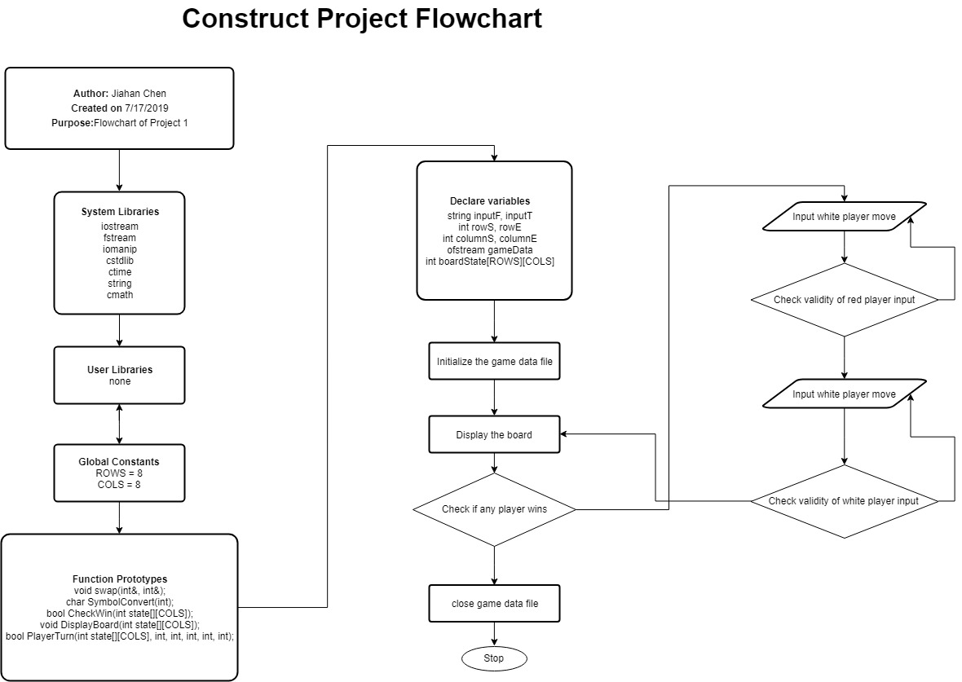

Pseudo Code
Initialize the board.
Loop // loop the game moves
{
Loop // red player move
{
Red player input the move.
If(CheckMove() == valid) // check move validity
{
Save the game data into file.
Break.
}
Hint for invalid move.
}
If(CheckWin()) // check if the game is over.
{
Break.
}
Loop // white player move
{
Red player input the move.
If(CheckMove() == valid) // check move validity
{
Save the game data into file.
Break.
}
Hint for invalid move.
}
If(CheckWin()) // check if the game is over.
{
Break.
}
}

Outcome
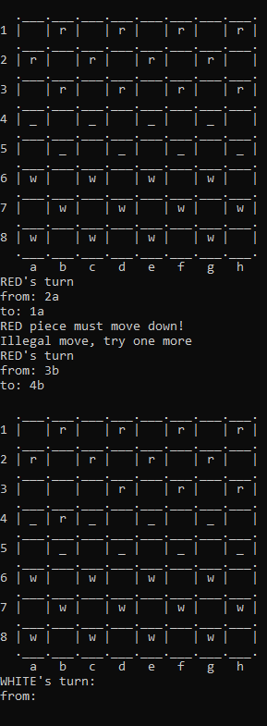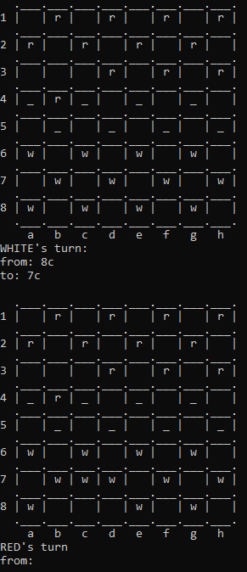
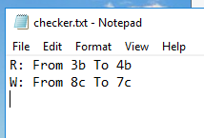

Reference
Gaddis, Tony. Starting Out with C++ from Control Structures to Objects. 8th ed., Pearson, 2014.
Savitch, Walter, and Kenrick Mock. Problem Solving with C++. 10th ed., Pearson, 2017.

